Professor Mallios’s 2020 Summer Archaeological Field School and Lab Course
(June 1-20 and July 20-August 7)
Nathan “Nate” Harrison Site, Palomar Mountain, San Diego County, CA
and SDSU campus (HAMR Lab-Hardy Tower 70
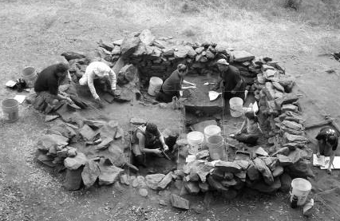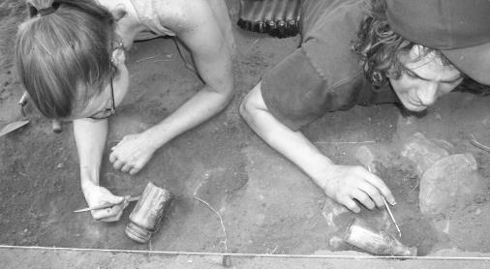
Admission to this archaeological field school is restricted.
You must apply and be accepted to get the add code from Dr. Mallios.
If you are interested in this archaeological field program, check ONE of the following two boxes only:

□ ANTH 312 and 561 (First-time undergraduates; 6 credits total)
The field class (312) is June 1-20 and requires living on Palomar Mountain Monday-Friday (and the last Saturday). You will receive 3 credits for this course. The lab class (561) is July 20-August 7 (Monday-Friday, 8am-4:30pm) in SDSU’s HAMR Lab (HT70). You will receive an additional 3 credits for this course.

□ ANTH 560 and 561 (Returning undergraduates and graduate students; 6 credits total)
The field class (560) is June 1-20 and requires living on Palomar Mountain Monday-Friday (and the last Saturday). You will receive 3 credits for this course. The lab class (561) is July 20-August 7 (Monday-Friday, 8am-4:30pm) in SDSU’s HAMR Lab (HT70). You will receive an additional 3 credits for this course.

Name: _______________________ Red ID#: ______________________________
Telephone: ( ) ______________ E-mail: ________________________________

◘ With this completed application form, also include a one-page statement of personal and professional reasons for wanting to participate in the class. Turn in these materials to Dr. Mallios at <smallios@sdsu.edu>. You will also need a letter of recommendation that addresses your ability to work well with others and complete challenging work sent directly to Dr. Mallios at <smallios@sdsu.edu>.

◘ Students who have joined Dr. Mallios on the Nathan “Nate” Harrison Historical Archaeology Project in previous field seasons do not need to submit the one-page resume and one-page statement of personal and professional reasons for wanting to participate in the class. They need only fill out and submit this form.

◘ Review of applications begins March 2, 2020. There are limited spots in this class. There will be additional food and camping fees for this program. The exact cost is dependent on the success of various grant applications that are pending.

